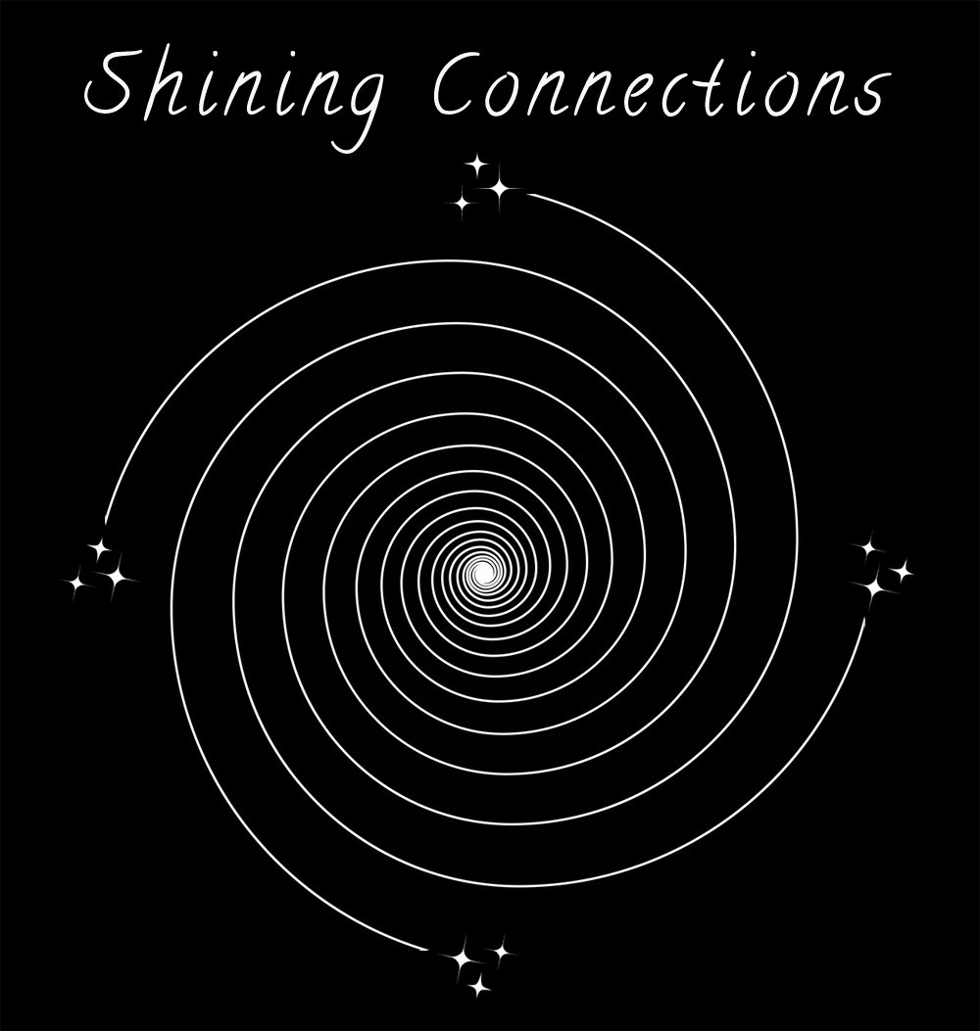 Candace Leila, 707.972.0606
shiningconnection.com | shining.one@icloud.com

MEMORIAL QUESTIONNAIRE
Memorial Questions to “explore the essence” of your loved one.

Full name:

Maiden:

Date of Birth:

Location:

Childhood Family / Nationality / Heritage / Lineage:

Primary Familial Roles (Role as Daughter / Son / Sibling / Mother or Father):

Family Faith:

Education / Certifications:

Role Models:

Important Friendships:

Career:

Marriage / Spouse / Mate Name:

Parents’ Names:

Children(s) Names:

Sibling(s) Names:

Extended Family Member Names:

Religion/Spirituality/Rituals/Healers/Teachers/Angels/Miracles:

Did this person pray with others? / church / group / service organization / circle:

Beliefs regarding birth & death / Heaven & Hell / afterlife / reincarnation / near death experiences:

Dreams /Deepest Desires /Greatest Joys:

What was most nurturing / revitalizing for their soul essence:

When were they most themselves?

Who did they feel most loved by?

Who did they love most?

Proudest Achievements /Peak Experiences:

Unique Personal Traits:

Most Memorable Qualities:

Challenges /Struggles / Regrets / Prejudices:

Favorites:

Music/Song

Poet

Artist

Flower

Season

Movie

Book

Photo

Food

Hobbies

Sports

Community Involvement:
Service Organization

Group / Club

Volunteer

Donation Recipients

Favorite Nature Places:

Pets Names:

Most Often Shared Stories:

What type of story was this (heartwarming / inspiring / profound / tender / humorous, etc):

Discuss (health history / diagnosis / treatment / hospital / accident / disability / premature death / donation of organs):

Self-Perception (survivor / brave / contemplative / victim / peaceful / acceptance):

Emotional State (lonely / isolation / acceptance / fear / unfinished business /suffer / anger / rage / pain / anticipation / joy):

End of Life Experience (last days / watching & waiting / withdrawal / perspective / comprehension / in the end):

Date & Time of Passing:

How does your family approach grieving/letting go/closure:

What does the memorial look like to you (somber / celebratory /light-hearted / contemplative / spiritual / etc.):

How would you like to memorialize your loved one (honor with ceremony / ritual / prayer / photos / music / plaque or stone / program, etc.):

What have you learned from this person:

How will your life change without this person’s presence in the physical form:

Additional Thoughts:

